Assignment -5

**Student Name:** Palak **UID:** 22BCS12960

**Branch:**CSE **Section/Group:**605-B

**Semester:** 5 **Date of Performance:**  05/03/25

**Subject Name:** AP **Subject Code: 22CSP-351**

**Q.1** [**389. Find the Difference**](https://leetcode.com/problems/find-the-difference/)

class Solution {

public:

char findTheDifference(string s, string t) {

for(int i=0;i<s.size();i++){

t[i+1]+=t[i] - s[i];

}

return t[t.size()-1];

}

};

Output :

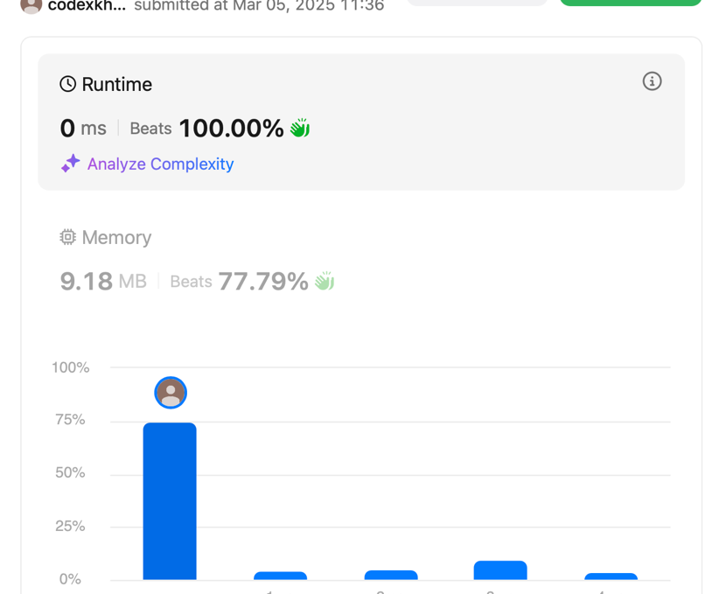

**Q.2** [**414. Third Maximum Number**](https://leetcode.com/problems/third-maximum-number/)

class Solution {

public:

int largestPerimeter(vector<int>& nums) {

sort(nums.begin(),nums.end());

for(int i=nums.size()-1;i>1;i--){

if(nums[i]<nums[i-1]+nums[i-2]){

return nums[i]+nums[i-1]+nums[i-2];

}

}

return 0;

}

};

Output : 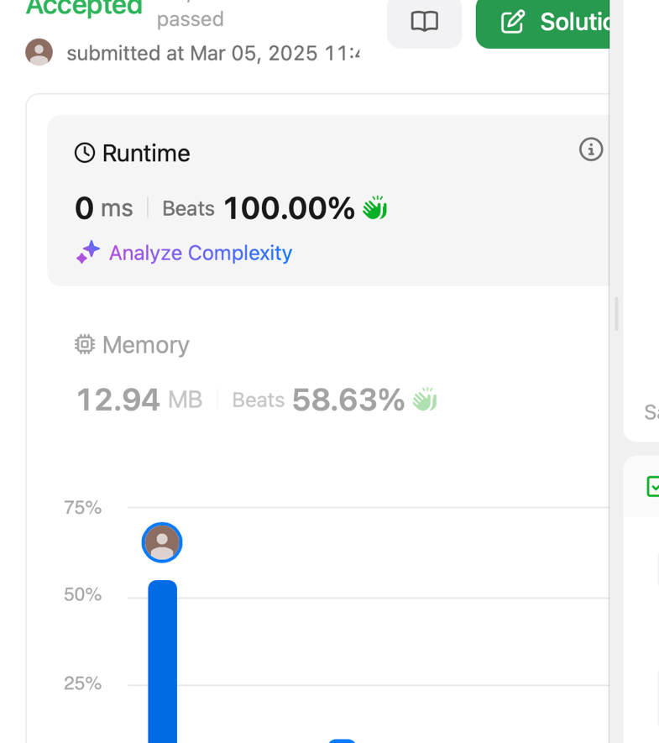

**\**

**Q.3** [**451. Sort Characters By Frequency**](https://leetcode.com/problems/sort-characters-by-frequency/)

class Solution {

public:

typedef pair<char, int> P;

string frequencySort(string s) {

vector<P> vec(123);

for(char &ch : s) {

int freq = vec[ch].second;

vec[ch] = {ch, freq+1};

}

auto comp = [&](P &p1, P &p2) {

return p1.second > p2.second;

};

sort(begin(vec), end(vec), comp);

string result = "";

for(int j = 0; j <= 122; j++) {

result += string(vec[j].second, vec[j].first);

}

return result;

}

};

Output :

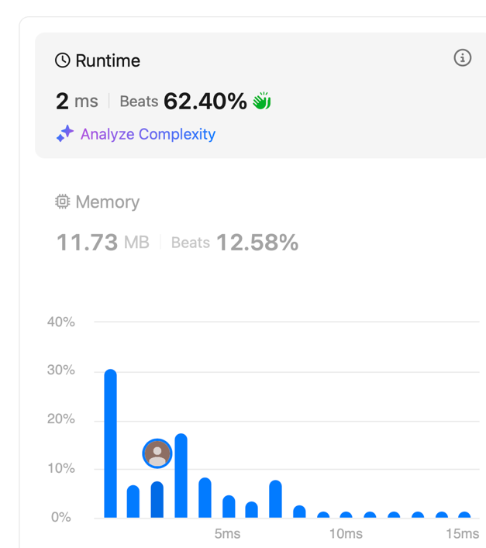

**Q.4** [**452. Minimum Number of Arrows to Burst Balloons**](https://leetcode.com/problems/minimum-number-of-arrows-to-burst-balloons/)

class Solution {

public:

int findMinArrowShots(vector<vector<int>>& points) {

int n = points.size();

sort(begin(points), end(points));

vector<int> prev = points[0];

int count = 1;

for (int i = 1; i < n; i++) {

int currSp = points[i][0];

int currEp = points[i][1];

int prevSp = prev[0];

int prevEp = prev[1];

if (currSp > prevEp) {

count++;

prev = points[i];

} else {

prev[0] = max(prevSp, currSp);

prev[1] = min(currEp, prevEp);

}

}

return count;

}

};

OUTPUT :

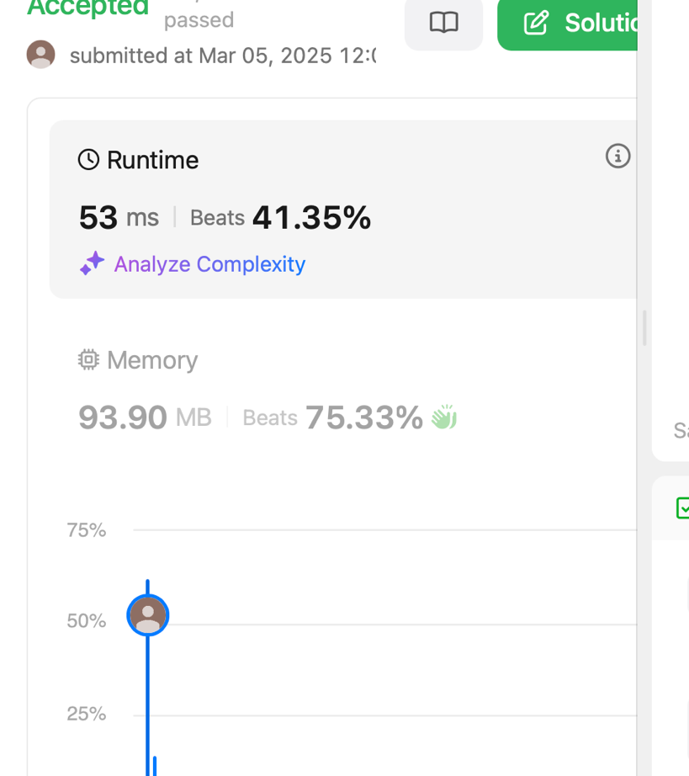

Q.6. [**881. Boats to Save People**](https://leetcode.com/problems/boats-to-save-people/)

class Solution {

public:

int numRescueBoats(vector<int>& people, int limit) {

int n = people.size();

sort(begin(people) , end(people));

int i = 0 ;

int j = n-1;

int boats = 0 ;

while(i <= j){

if(people[j] + people[i] <= limit){

i++;

j--;

}

else {

j--;

}

boats++ ;

}

return boats;

}

};

Output :

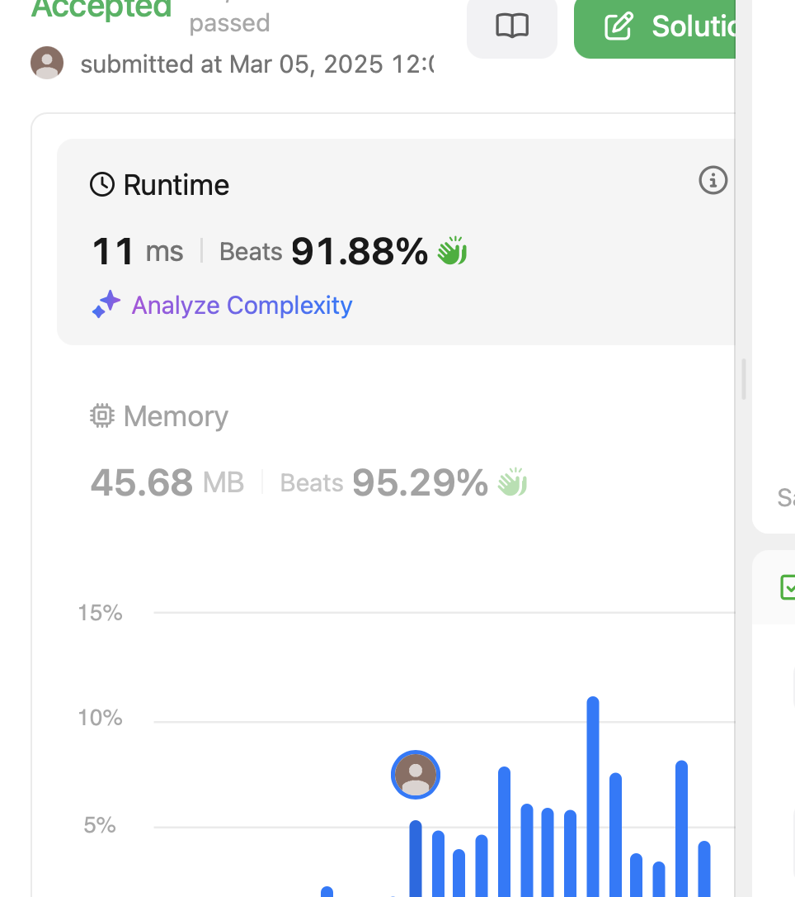

# Q.7. [973. K Closest Points to Origin](https://leetcode.com/problems/k-closest-points-to-origin/)

#include <queue>

#include <vector>

using namespace std;

class Solution {

public:

vector<vector<int>> kClosest(vector<vector<int>>& points, int k) {

priority_queue<pair<int, vector<int>>> maxHeap;

for (const auto& point : points) {

int x = point[0];

int y = point[1];

int distance = x * x + y * y;

maxHeap.push({distance, point});

if (maxHeap.size() > k) {

maxHeap.pop();

}

}

vector<vector<int>> result;

while (!maxHeap.empty()) {

result.push_back(maxHeap.top().second); maxHeap.pop(); }

return result;

}

};

Output:

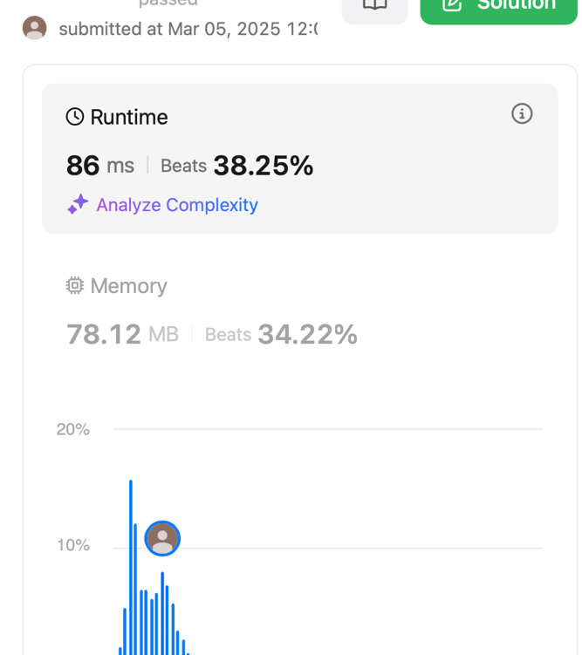

**Q.8** [**1338. Reduce Array Size to The Half**](https://leetcode.com/problems/reduce-array-size-to-the-half/)

class Solution {

public:

int minSetSize(vector<int>& arr) {

unordered_map<int, int> cnt;

for (int x : arr) ++cnt[x];

vector<int> frequencies;

for (auto [_, freq] : cnt) frequencies.push_back(freq);

sort(frequencies.begin(), frequencies.end());

int ans = 0, removed = 0, half = arr.size() / 2, i = frequencies.size() - 1;

while (removed < half) {

ans += 1;

removed += frequencies[i--];

}

return ans;

}

};

Output :

